

SAVEETHA SCHOOL OF ENGINEERING

SAVEETHA INSTITUTE OF MEDICAL AND
TECHNICAL SCIENCES

DEPARTMENT OF COMPUTER SCIENCE AND ENGINEERING

LIST OF EXPERIMENTS

COURSE CODE : CSA4001
COURSE NAME : MANAGEMENT INFORMATION SYSTEM

10 Draw a use case diagram for Library Management System is an automation system used to manage a library and the different resource management required in it like cataloguing of books, allowing check out and return of books, invoicing, user management, etc. The user can search for books details using few book properties (Book ID, Title, Author, and Publisher). Searching should return details about all the book copies that match the search query.

AIM:
To create a Use Case Diagram for a Library Management System, representing the interactions between users and the system for managing resources such as book cataloging, check-out, return, invoicing, and user management.

PROCEDURE:
• Identify Actors:
The primary actors are:
- User: The person searching for books, checking out or returning them.
- Librarian: Manages the catalog of books, processes check-outs/returns, and generates invoices.
- System: The library automation system handling all functionalities.
• Identify Use Cases:
Use cases include:
- Search Books: Allows users to search for books by properties like Book ID, Title, Author, and Publisher.
- View Book Details: Displays information on books that match the search query.
- Check-out Book: Allows users to check out a book.
- Return Book: Manages the return of a book to the library.
- Generate Invoice: The librarian generates invoices for borrowed books.
- User Management: Manages user profiles and account information.
- Manage Catalog: The librarian adds, removes, and updates books in the catalog.
• Establish Relationships:
- Users interact with the system to search for books, check-out, and return them.
- Librarians manage the catalog, users, and invoices.
- The system processes these actions based on user input and librarian commands.
• Generate Use Case Diagram:
Create a visual representation of the use cases and actors interacting with the system.

OBSERVATION:

USECASE DIAGRAM:
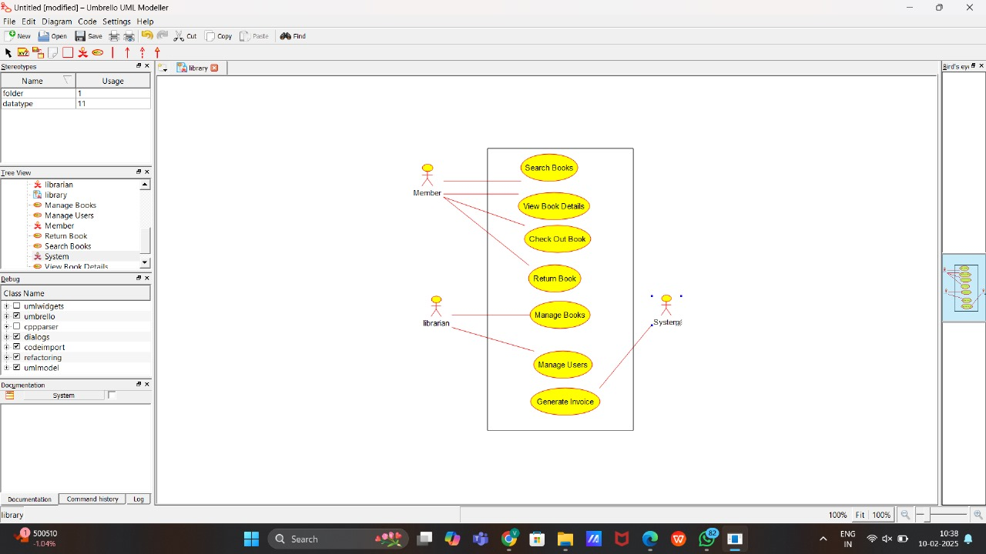

CLASS DIAGRAM:
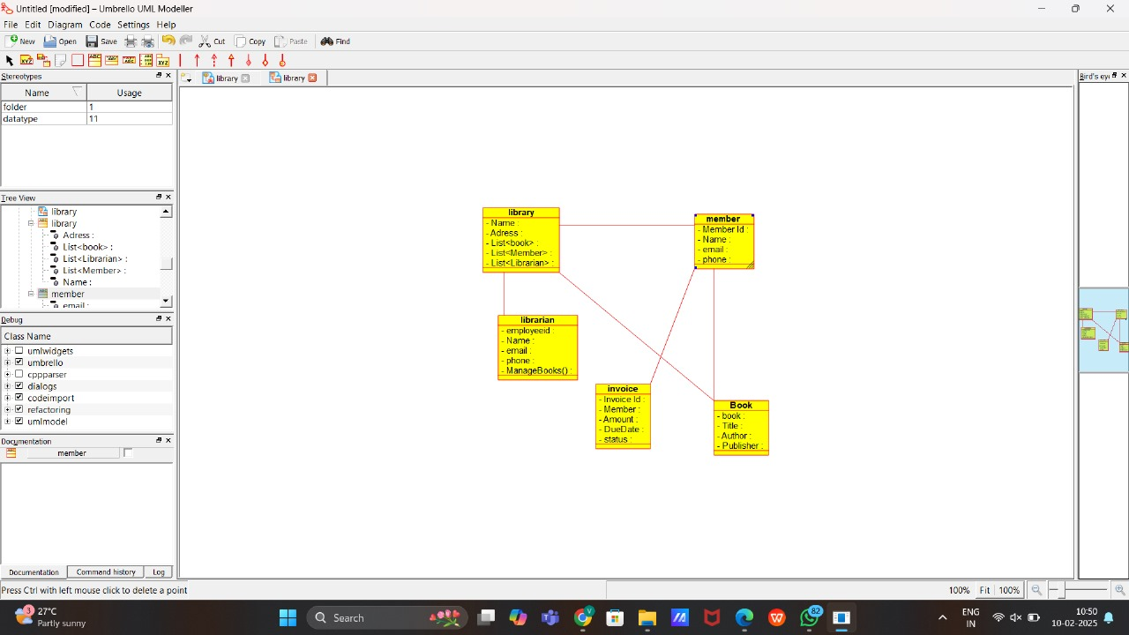
ACTIVITY DIAGRAM:
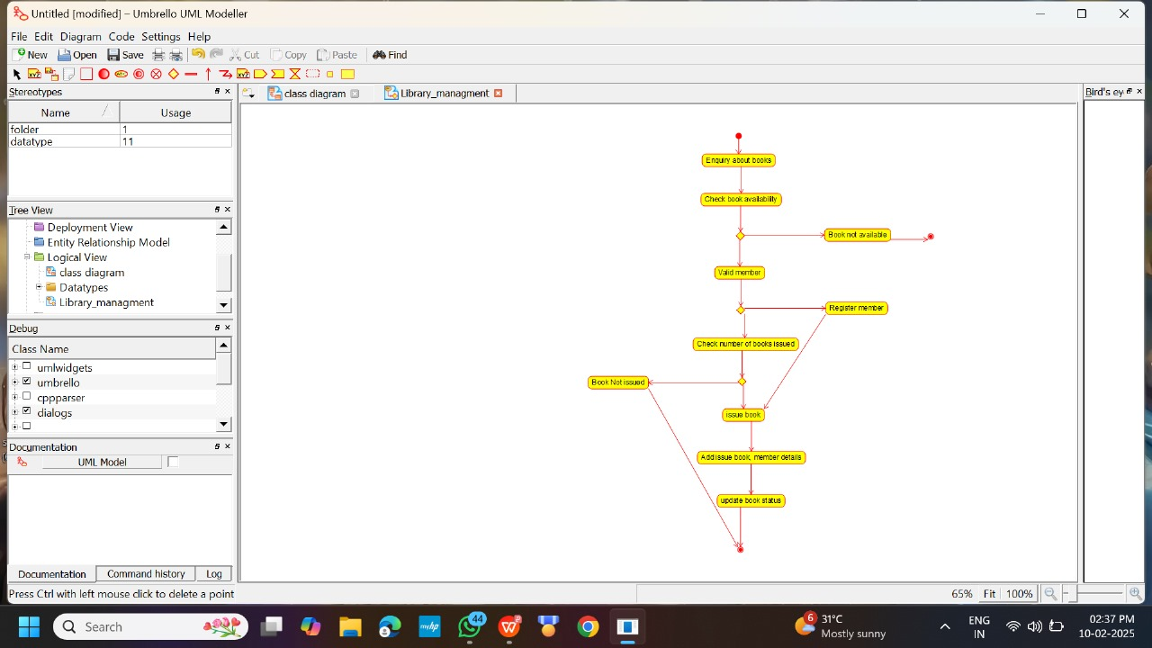

STATE DIAGRAM:
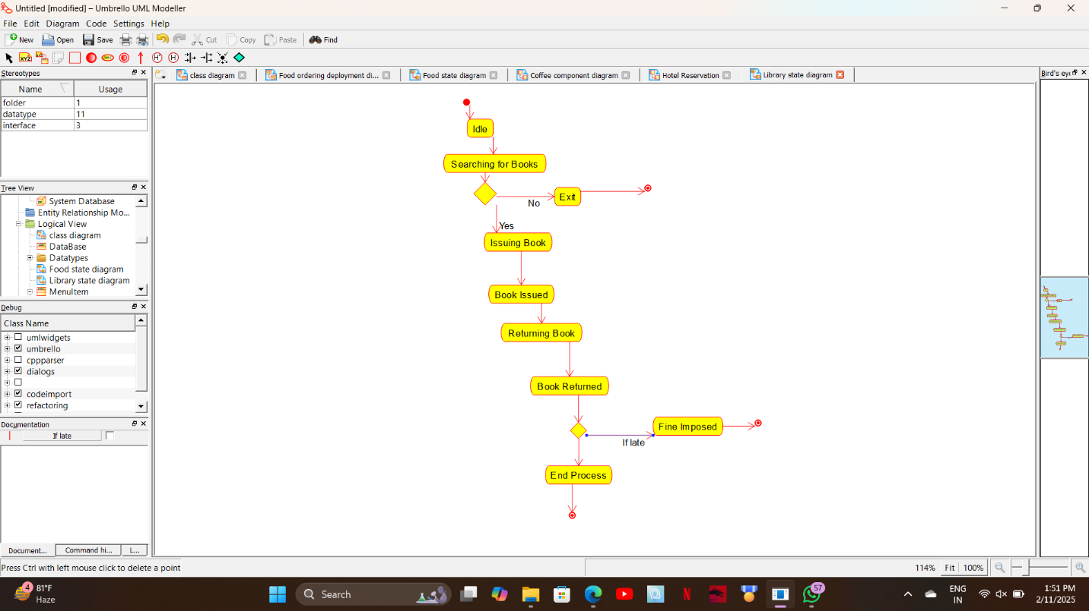

SEQUENCE DIAGRAM:
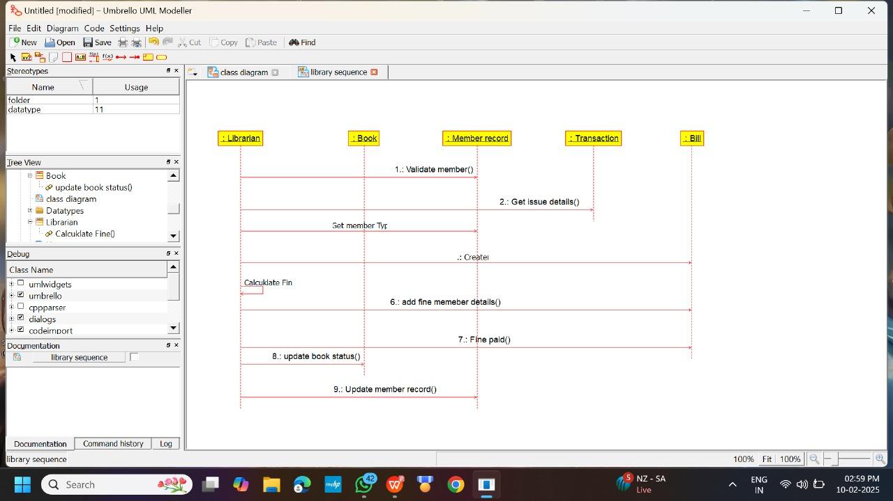

COMPONENT DIAGRAM:
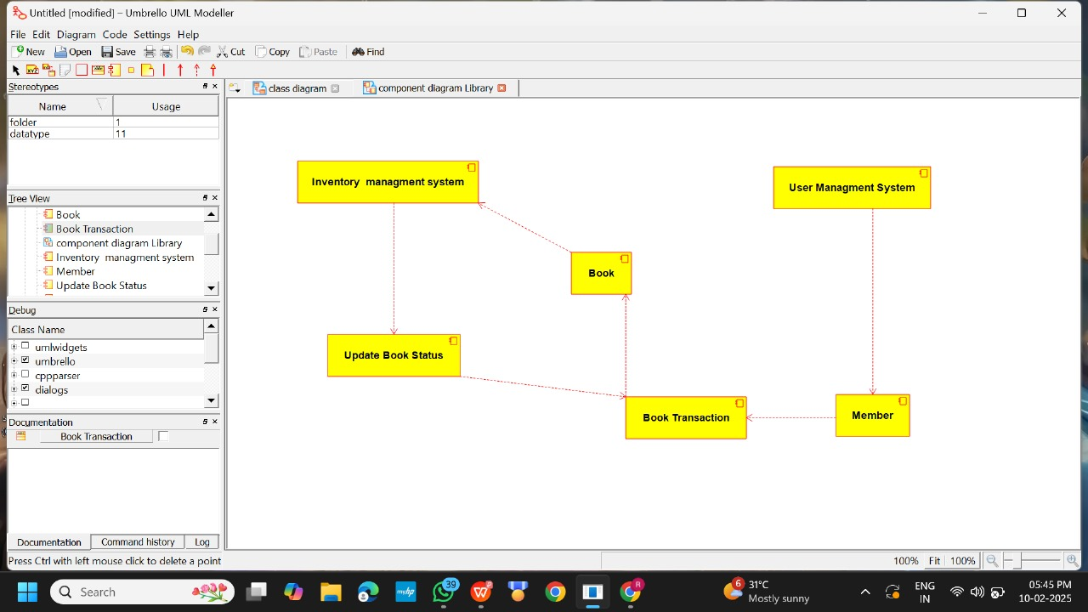

DEPLOYMENT DIAGRAM:
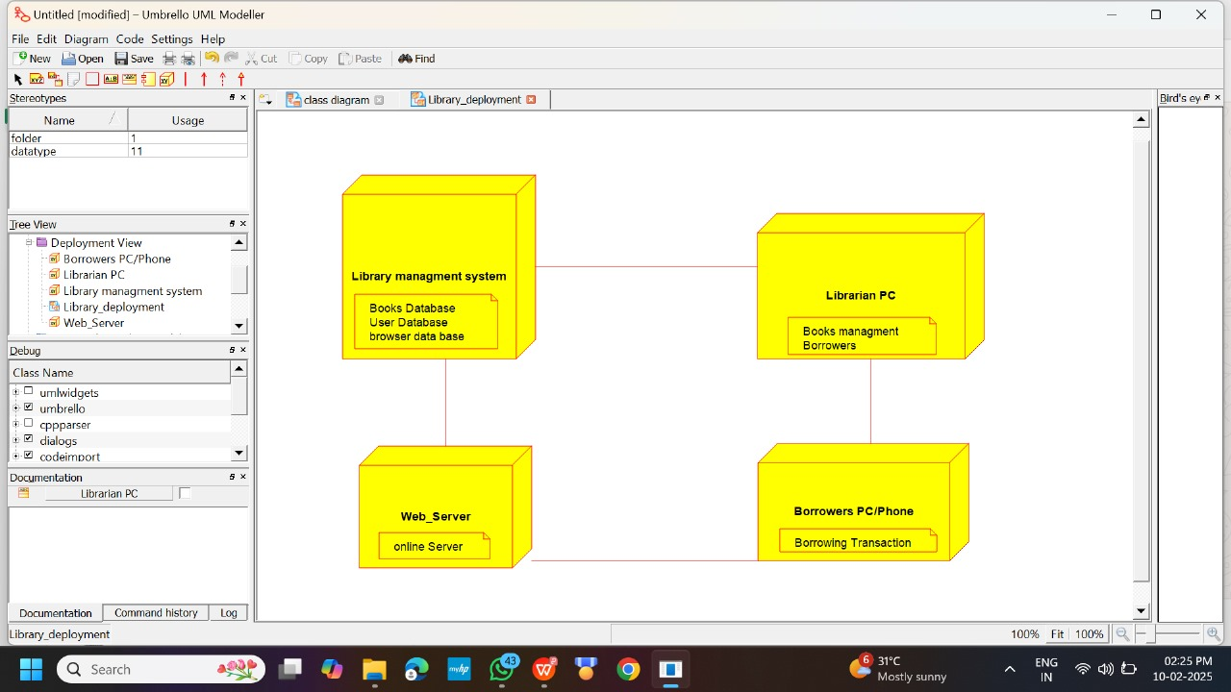

RESULT:

The UML Diagram for the Library Management System has been successfully created, illustrating the interactions between users, librarians, and the system, covering all key functions such as book search, check-out, return, invoicing, and user management.

